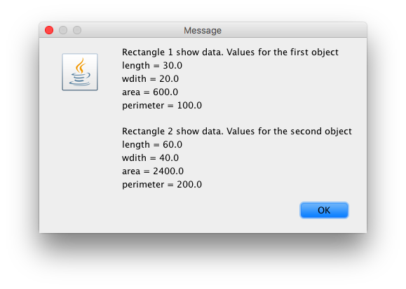

**import** javax.swing.JOptionPane;

**public** **class** TestRectangle {

**public** **static** **void** main ( String args[] )

{

//object ... > (name of the class_first one) (name of the object) = new consctrcutor(variable,variable)

//to use the object

//send the input from object to the constructor, becomes integers and assigns new variable.

//those variable are private

//class 1, methods and construcotr

//object.method

String in,out;

**double** lengtha, widthb;

String display, display2;

display2 = "You will be prompted to enter the dimensions of 2 rectangles";

JOptionPane.*showMessageDialog*(**null**,display2);

in = JOptionPane.*showInputDialog*("Rectangle 1\n Enter the length");

//Convert the numb from a string to a double

lengtha = Double.*parseDouble* (in);

//Input the second number as a string

in = JOptionPane.*showInputDialog*("Rectangle1\n Enter the width number");

//Convert the numb from string to a double

widthb = Double.*parseDouble*(in);

Rectangle rect1 = **new** Rectangle(lengtha,widthb);

in = JOptionPane.*showInputDialog*("Rectangle 2\n Enter the length");

//Convert the numb from a string to a double

lengtha = Double.*parseDouble* (in);

//Input the second number as a string

in = JOptionPane.*showInputDialog*("Rectangle2\n Enter the width");

//Convert the numb from string to a double

widthb = Double.*parseDouble*(in);

Rectangle rect2 = **new** Rectangle(lengtha,widthb);

display = "Rectangle 1 show data. Values for the first object\n" + "length = " + rect1.getLength ( ) + "\n" + "wdith = " + rect1.getWidth ( ) + "\n"

+ "area = " + rect1.compArea ( ) + "\n" + "perimeter = "+ rect1.compPerimeter ( ) + "\n\n"

+ "Rectangle 2 show data. Values for the second object\n" + "length = " + rect2.getLength ( ) + "\n" + "wdith = " + rect2.getWidth ( ) + "\n"

+ "area = " + rect2.compArea ( ) + "\n" + "perimeter = "+ rect2.compPerimeter ( );

JOptionPane.*showMessageDialog*(**null**,display);

}

//construct name has to be the same as the class

// to show the input. rect1.getlength()

}